**PART E: Canadian Museum of Science and Technology Database Migration Report**

By: Richard Granger

The following actions were taken for moving the data from our old database schema to the new unified museum database design agreed upon by the 5 museums. We will outline how the data was moved to each table in the new design one by one:

**Doors:**

My previous database design relied on character identifiers for locations, and so for this table the data was migrated manually record by record.

Testing: I produced a query of the new records and compared it by hand to the prior data.

**ExhibitionLocations:**

My previous database design was fairly consistent with the new database design, so most of the information was easily copied over, with the museum name being filled in with our name. We did notice that parts of the travelling exhibition were missing, so they were then inserted by hand into the new database.

Testing: We produced a query that described the exhibitionlocations within the new database design, and it showed that all data was moved properly and that the erroneous exhibits had been corrected. As shown here:

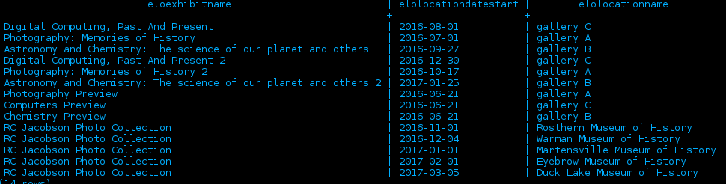

**Exhibitions:**

The design of our exhibitions table was mostly similiar to the design of the team database, so most data was copied over without issue. We had a slight issue with travelling exhibitions, but after a manual adjustment the data was corrected.

Testing: We produced a query of the old and new data and examined both to be consistent, and thus were satisfied with the quality of the data transferrence.

**ExhibitionWorks:**

This data was almost perfectly identical with the new database design, and required no readjustment, it was simply added to the database without having to change anything.

Testing: The data was perfectly preserved when we did a query in the new design as shown below:

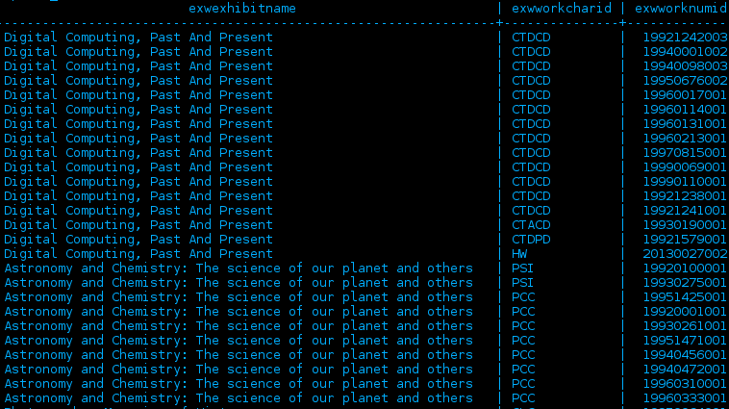

**Locations:**

The data in our museum did not record a person for each location, so we had to mess with the data a little bit here. We mass transferred the data, using temporary owners, then adding the proper owners and changing the locations to the right owners. The locations in the new design now had their proper owners according to the new database design.

Testing: Producing a query of the locations within our museum and cross-referencing the information with our old database showed that the data had transferred properly.

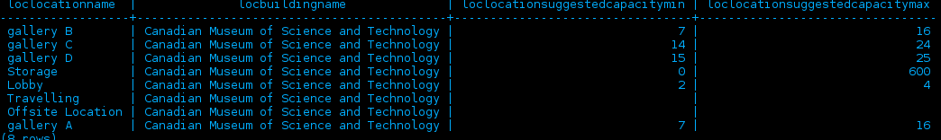

**Owners:**

The data for owners in our museum was both in the owners table and in the loaninfo table. We moved over the data from both tables into the new database. We were also required to add new owners for the building’s in which we had sent works abroad and works that we had sold.

Testing: We tested this by producing a query and comparing it to the original database to ensure that BOTH loaninfo and owners had been moved over successfully. The query was correct and produced the following:

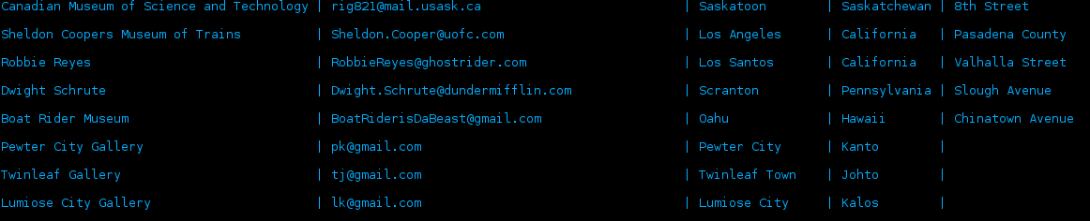

As you can see places that we have loaned to and places that have had travelling exhibitions, it has all transferred successfully.

**SponsorExhibitions:**

We fairly easily added this data from our old database, and cross-referenced old budget slips to enter the amount that Rogers Incorporated paid to sponsor each exhibition. This information was entered into the database along with the data that we already had.

Testing: A query showed that all 5 exhibitions that were sponsored showed up with the correct exhibit name and sponsor amount.

**Themes:**

This data had not existed prior in our own database. We studied works carefully and added appropriate themes to certain works as the saw appropriately. The data was then added to the database.

Testing: This did not exist prior, so there is nothing to reference it to. We did however query the new design to ensure that the data was put in correctly:

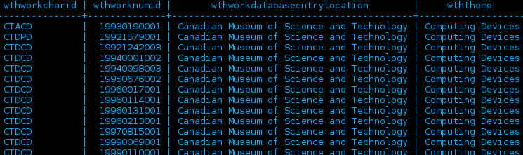

**WorkLocations:**

This data was mostly easy to transfer to the new database, however upon transferring we did notice some inconsistencies in the table, which we corrected manually. The data was then looked over manually and found to be accurate.

Testing: We produced a query that showed works locations comparing them to the original data in the database. The fixes that we implemented were shown in the new data and the correct data had transferred over properly.

**WorkOwners:**

This data transferred over relatively straighforwardely, with few manual changes needed.

Testing: Here we tested in queries to ensure that the ownership remained the same. We also produced a query to ensure that sold works showed a transfer in ownership, and they did, so everything transferred properly.

**Works:**

Transfering this data was very easy, simple copying, with manually inserting some data as necessary to the new database. Our old category fit nicely with the field of science way to sort works, so I ported some of those applicable category names to the new field of science part of the works table. I also had to create a function that ported my 4 digit year of creation and made it into a date to be in standard with the new database.

Testing: I produced a query and compared it to the data of the original database to ensure that everything had transferred properly. As shown as a sample below, it did:

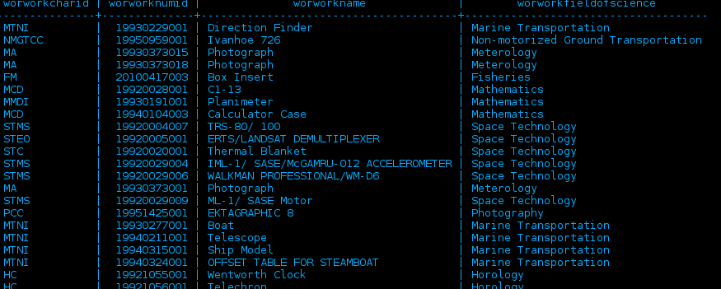

**WorksInsurance:**

Transferring this data over mainly consisted of moving the insurance value from the works table along with the appropriate data. We had to manually change some entries due to the value of the certain works changing due to being sent out in a travelling exhibition.

Testing: I produced a query, shown like the one below that ensured the new temporal data of insurance was proper, and compared it to my past database to ensure that there was no errors.

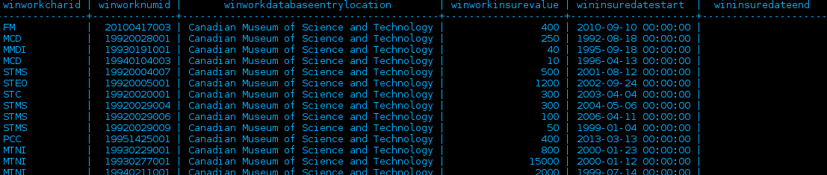

**WorksMedium:**

This one required almost no editing as the structure was almost identical, merely adding a museum field to the data as required. Everything migrated without issue here.

Testing: Produced a query of the materials that certain works were made out of and compared them to the original table to ensure data integrity.

**WorkTransaction:**

This data did not exist in our database prior, so going through physical records the entirety of the new data was meticulously constructed manually. This includes all events that our past museum had for transactions, they have now been entered into the new database schema.

Testing: No data existed prior, so we produced a query to ensure that the data made sense and was not corrupted, referencing it with physical records to check accuracy. An example is shown below:

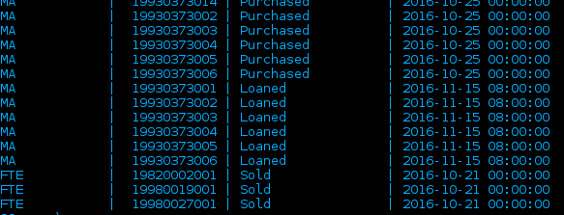

**All data is therefore now transferred to the new database schema properly.**